**Topic: AES Mini Project**

**Aim:** Create a program or something which contains of some topics of practicals and mini project

Example: Using Keypad

Pressing button 1 will turn on LED

Pressing button 2 will run servo motor

Pressing button 3 will use buzzer

**Description:**

* Arduino:

Arduino is an open-source platform used for building electronics projects. Arduino consists of both a physical programmable circuit board and a piece of software, or IDE runs on your computer, used to write and upload computer code to the physical board. Arduino UNO has 14 digital pins and 6 analog pins.

* Breadboard:

It is a way of constructing electronics without having to use a soldering iron. Components are pushed into the sockets on the breadboard and then extra 'jumper' wires are used to make connections.

* LED:

A light-emitting diode (LED) is a semiconductor device that produces light from electricity. LEDs last a long time and do not break easily.

* Resistors:

It’s a passive two-terminal electrical component that implements electrical resistance as a circuit element. In electronic circuits, resistors are used to reduce current flow, adjust signal levels, to divide voltages, bias active elements, and terminate transmission lines, among other uses.

* Keypad:

The buttons on a keypad are arranged in rows and columns. A 3X4 keypad has 4 rows and 3 columns, and a 4X4 keypad has 4 rows and 4 columns. Keypad 4x4 is used for loading numerics into the microcontroller. It consists of 16 buttons arranged in a form of an array containing four lines and four columns. It is connected to the development system by regular IDC 10 female connector plugged in some development system's port.

* Buzzer:

A buzzer or beeper is an audio signalling device, which may be mechanical, electromechanical, or piezoelectric (piezo for short). Typical uses of buzzers and beepers include alarm devices, timers, and confirmation of user input such as a mouse click or keystroke.

* Servo Motor:

A servo motor is an electrical device which can push or rotate an object with great precision. If you want to rotate and object at some specific angles or distance, then you use servo motor.

**Hardware Requirement:**

* 1 X Arduino
* 1 X Breadboard
* 1 X Resistor
* 1 X Keypad
* 1 X Buzzer
* 1 X Servo Motor
* Jump Wires

**Hardware Configuration:**

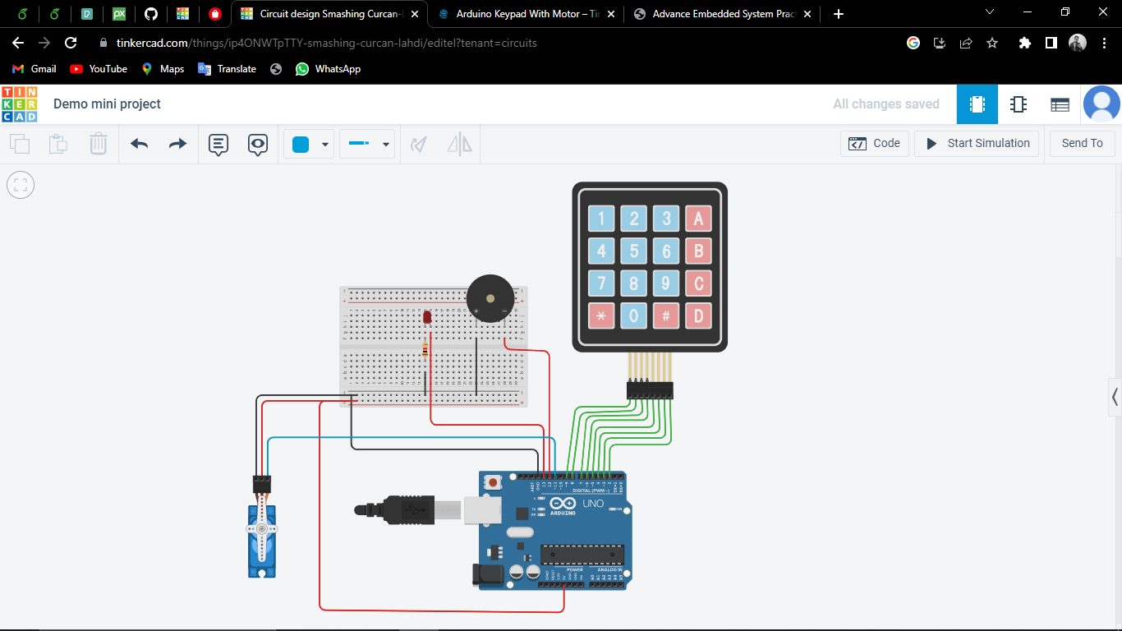

**Code:**

#include <Keypad.h>

#include <Servo.h>

Servo ServoMotor;

int position = 0;

const byte ROWS = 4; //four rows

const byte COLS = 4; //four columns

//define the symbols on the buttons of the keypads

String text = "";

char hexaKeys[ROWS][COLS] = {

{'1','2','3','A'},

{'4','5','6','B'},

{'7','8','9','C'},

{'*','0','#','D'}

};

byte rowPins[ROWS] = {9,8,7,6}; //connect to the row pinouts

byte colPins[COLS] = {5,4,3,2}; //connect to the column pinouts

//initialize an instance of class NewKeypad

Keypad customKeypad = Keypad( makeKeymap(hexaKeys), rowPins, colPins,4,4);

void setup(){

pinMode(13,OUTPUT);

pinMode(12,OUTPUT);

ServoMotor.attach(11);

ServoMotor.write(0);

Serial.begin(9600);

}

void loop(){

char key = customKeypad.getKey();

if(key != NO_KEY)

{

Serial.println(key);

if (key == '*')

{

text = "";

}

else

{

if (key == '#') //# key use for enter Button

{

Serial.println(text);

if (text == "1")

{

digitalWrite(13,HIGH);

digitalWrite(12,LOW);

ServoMotor.write(0);

}

if (text == "2")

{

digitalWrite(12,LOW);

digitalWrite(13,LOW);

ServoMotor.write(360);

}

if (text== "3")

{

digitalWrite(13,LOW);

digitalWrite(12,HIGH);

ServoMotor.write(0);

}

text = "";

}

else

{

text += key;

}

}

}

}

**Output:**

After you upload the code, open the serial monitor. When Pressing button 1 will turn on LED, Pressing button 2 will run server motor, Pressing button 3 will use buzzer